**AWS Multi VPC peering**

Requester VPC A and Accepter VPC B

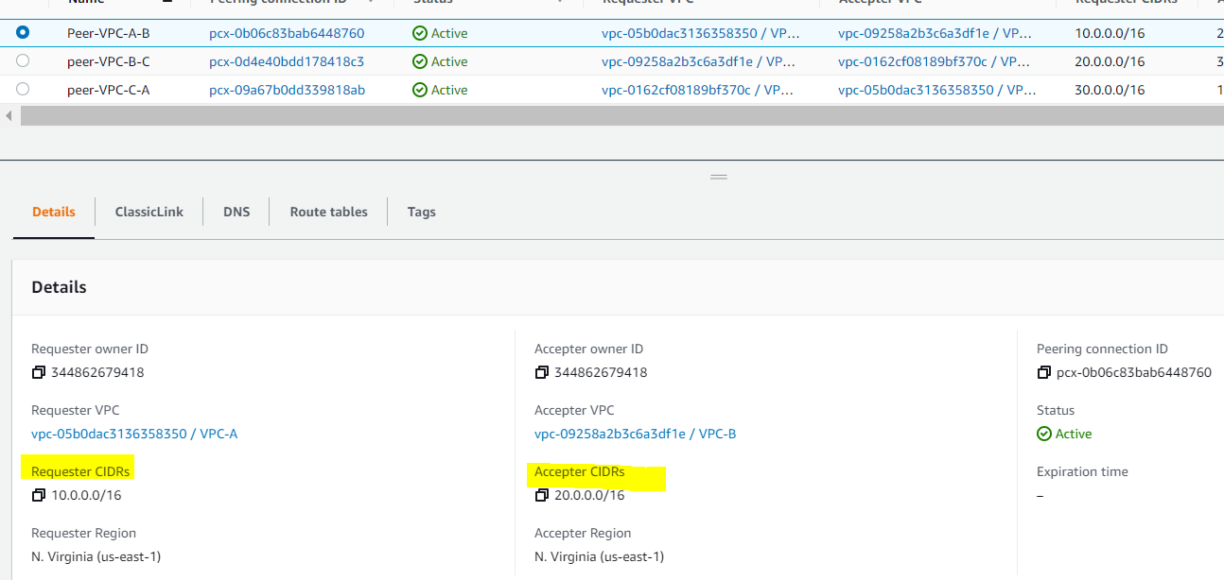

Requester VPC B and Accepter VPC C

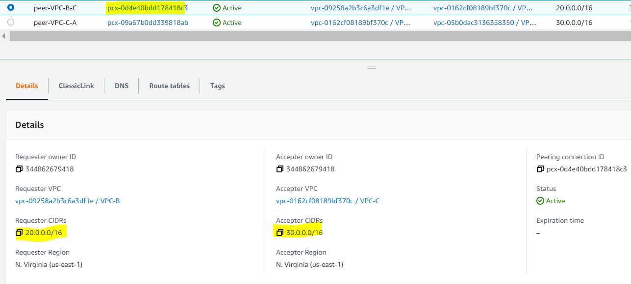

Requester VPC C and Accepter VPC A

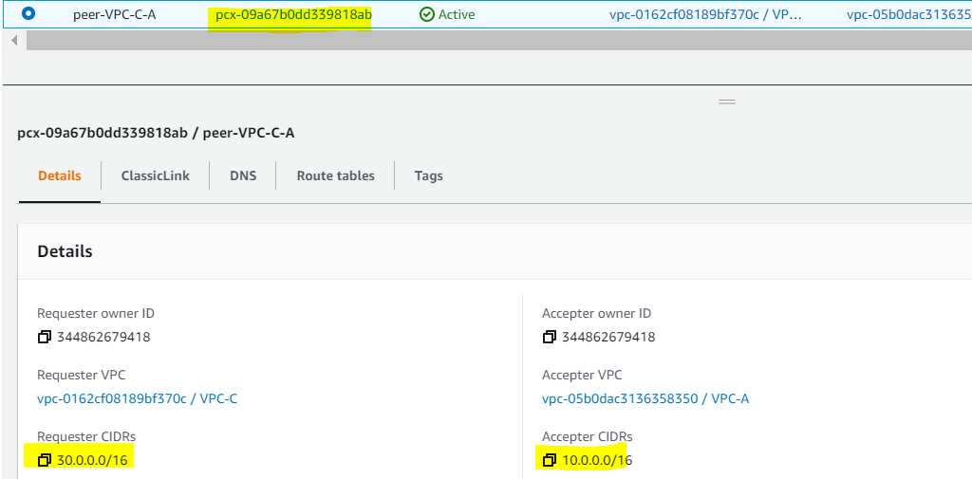

Add VPC B/C entry in VPC A RT

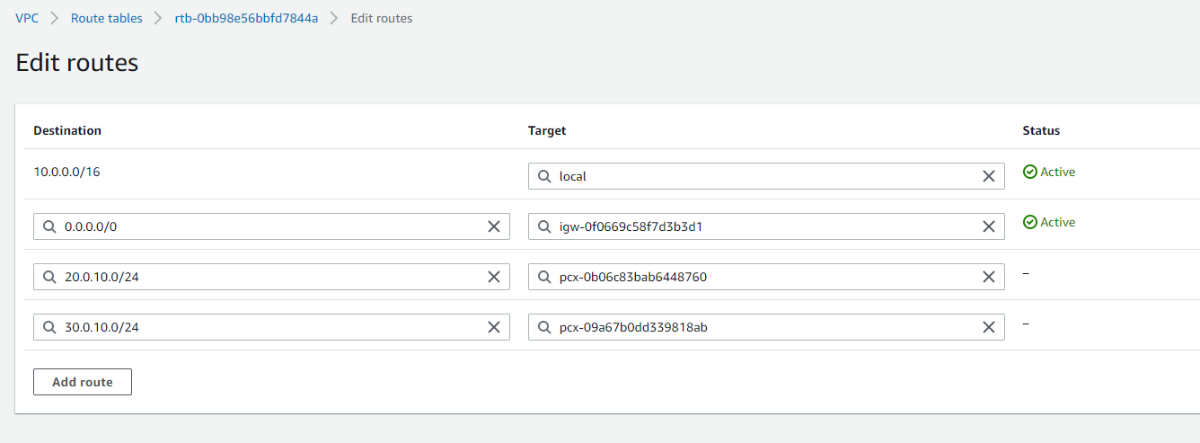

Add VPC A/B entry in VPC B RT

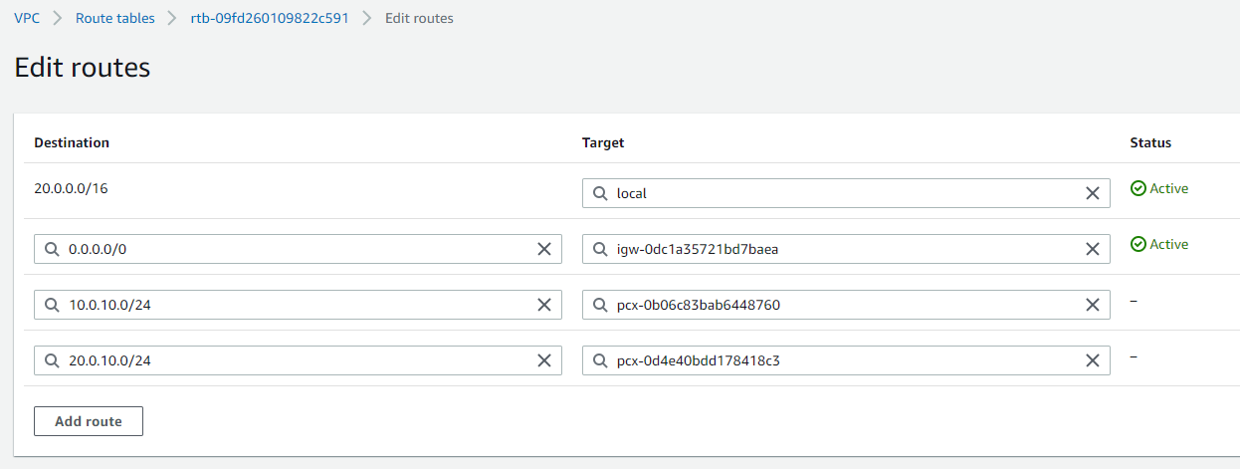

Add VPC B/C entry in VPC A RT

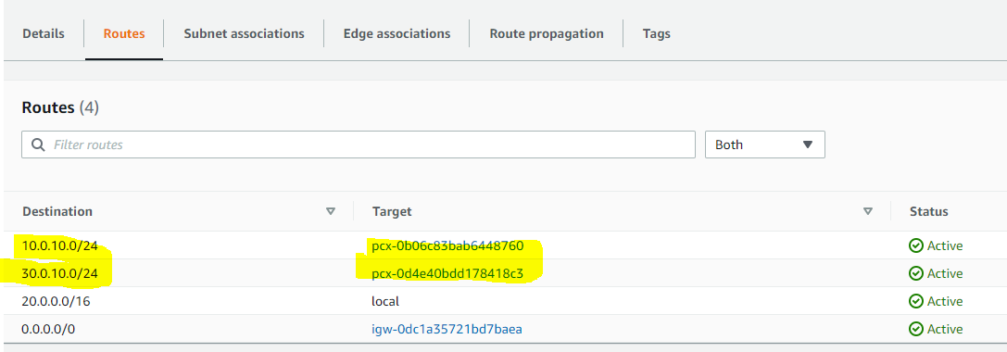

From VPC A ping is happening for VPC B/C

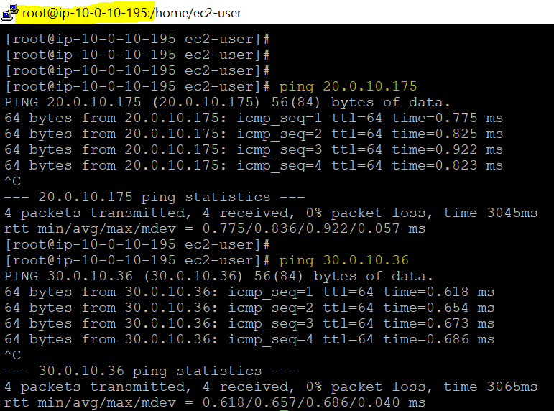

From VPC B ping is happening for VPC A/C

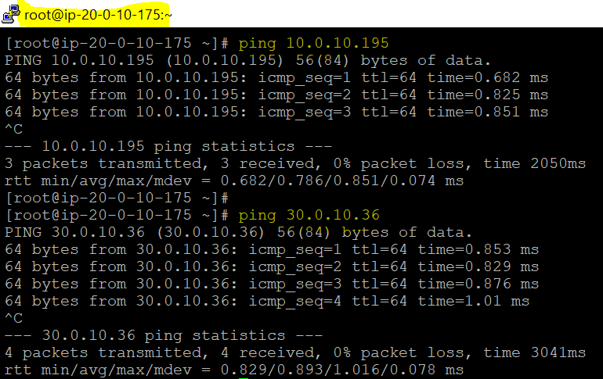

From VPC C ping is happening for VPC A/B

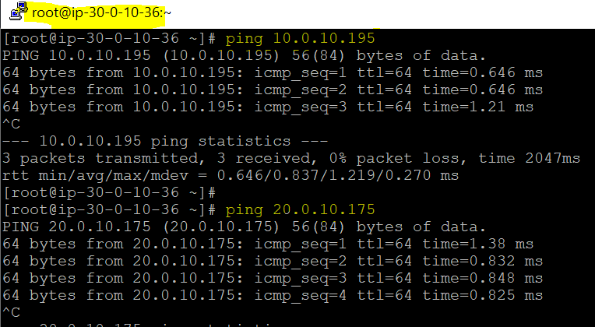

Try connecting server

